**REGISTRATION**

At first **Register** yourself by going to the URL **(**<https://tathyasathi.bangla.gov.in/>)

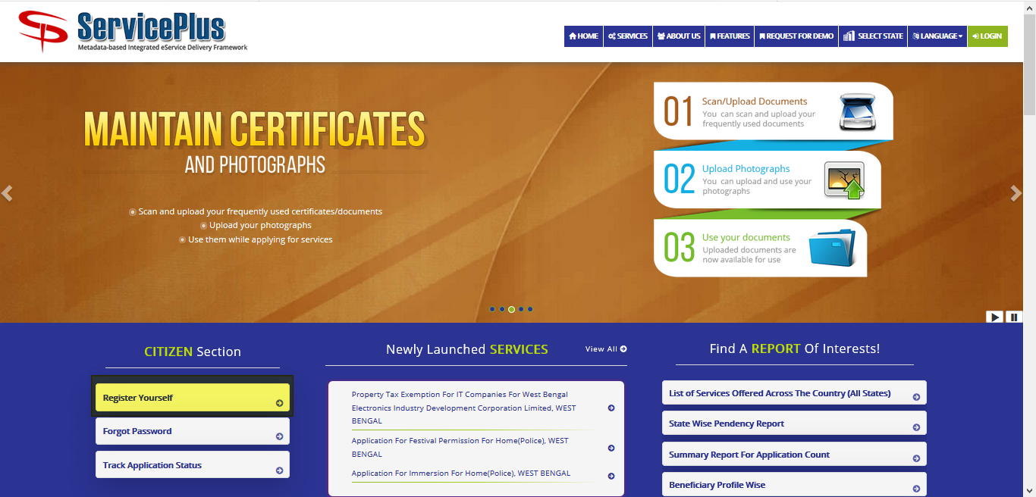

Fill in with proper **details** and **validate**.

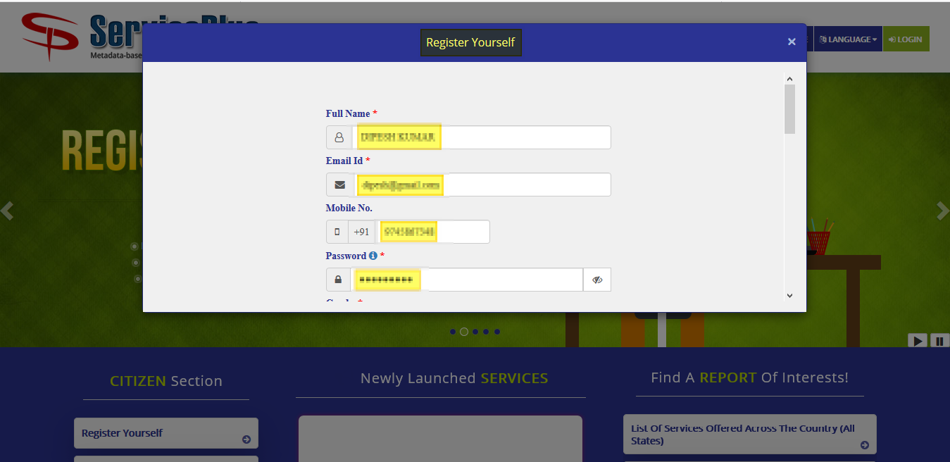

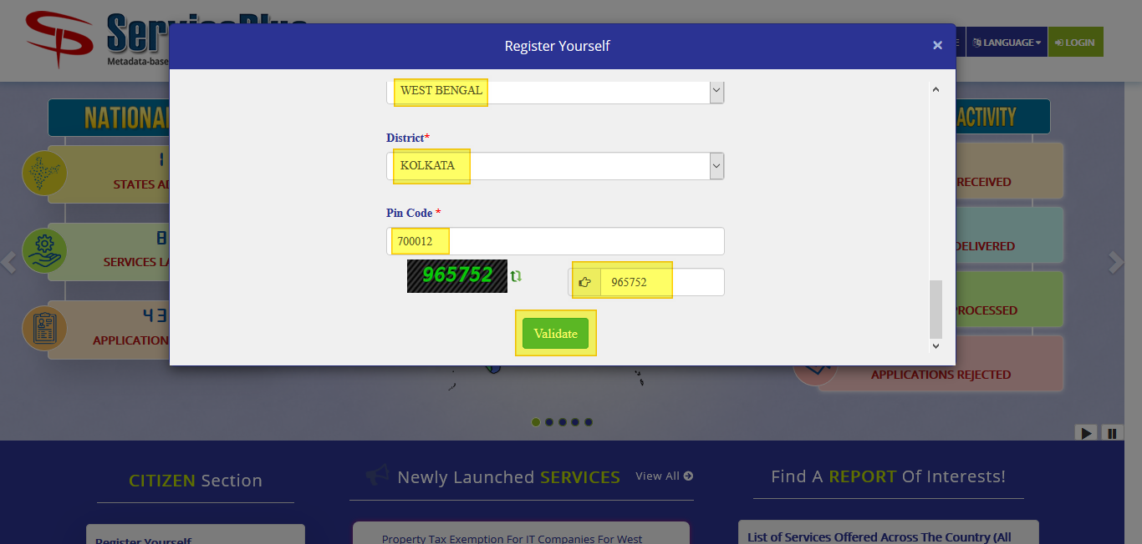

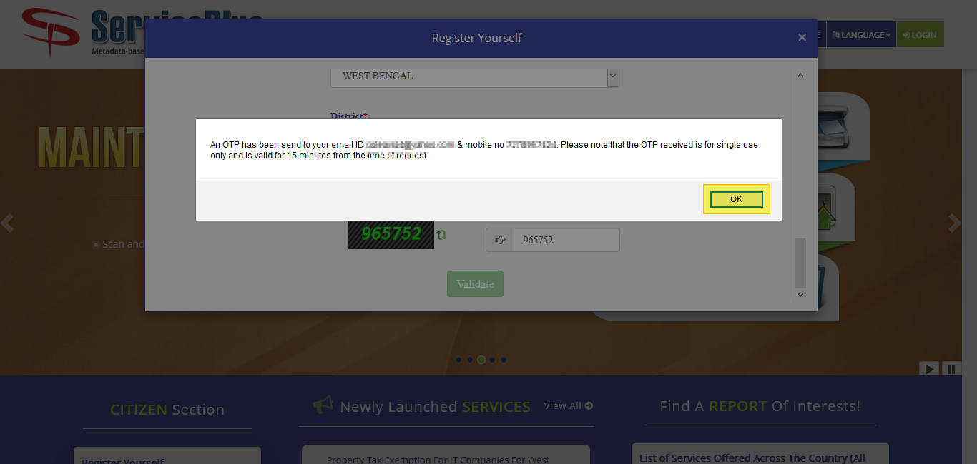

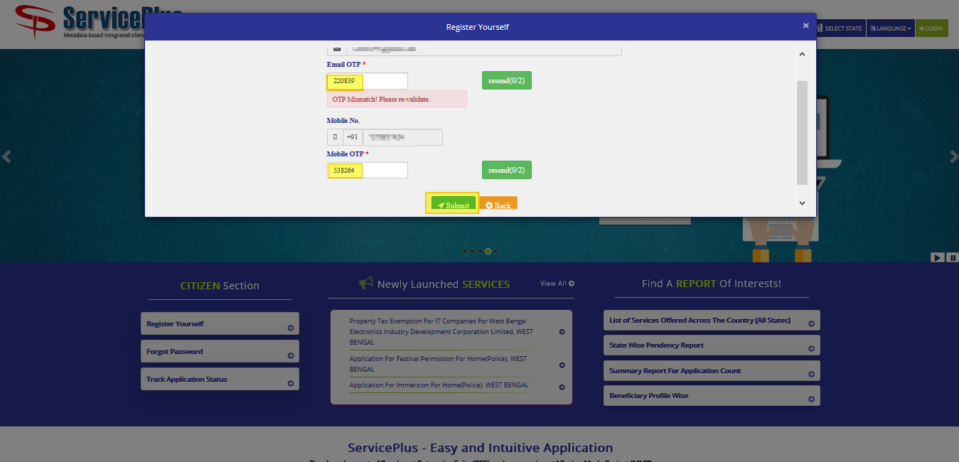

After successful registration.

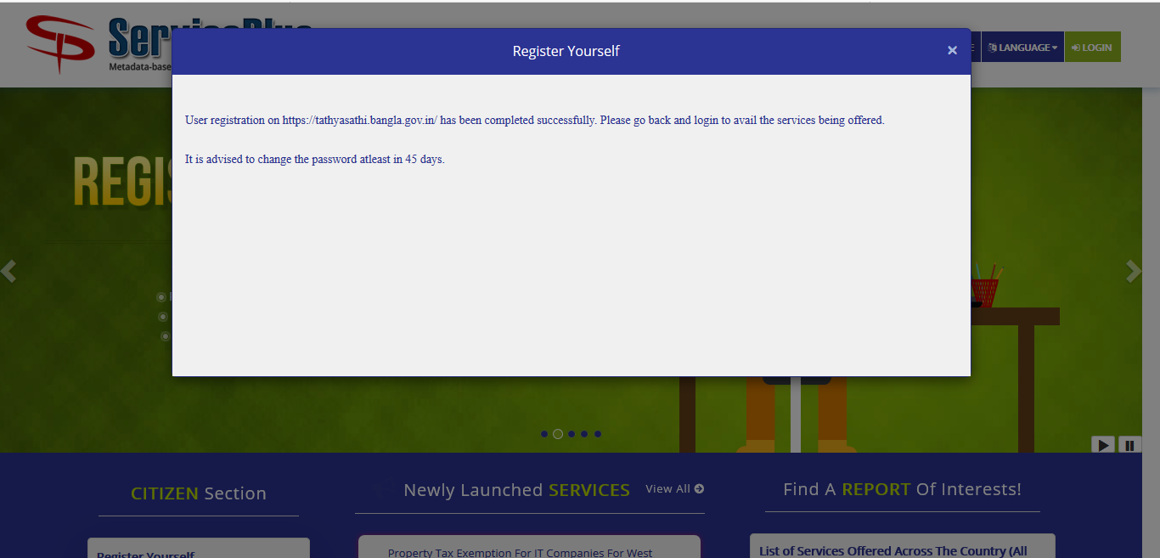

**APPLICATION PROCESS**

**Step -1:**

**Open Service plus web portal:** (<https://tathyasathi.bangla.gov.in/>) to apply for the **Application for Change of Flats in Bidhannagar Municipal Corporation Area.**

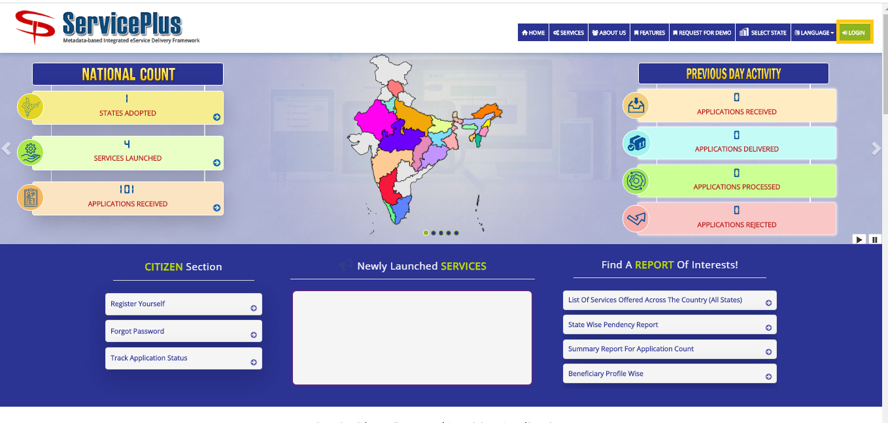

**Step -2:**

Login in the Service plus portal.

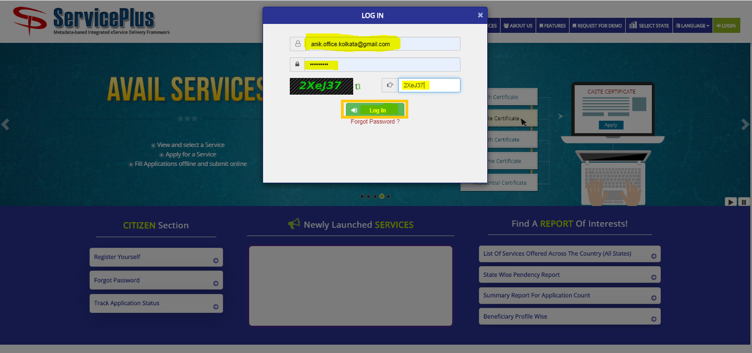

**Step -3:**

Now click “**Apply for services”** and select “**View all available services**”, then Select particular Service and Fill the form:

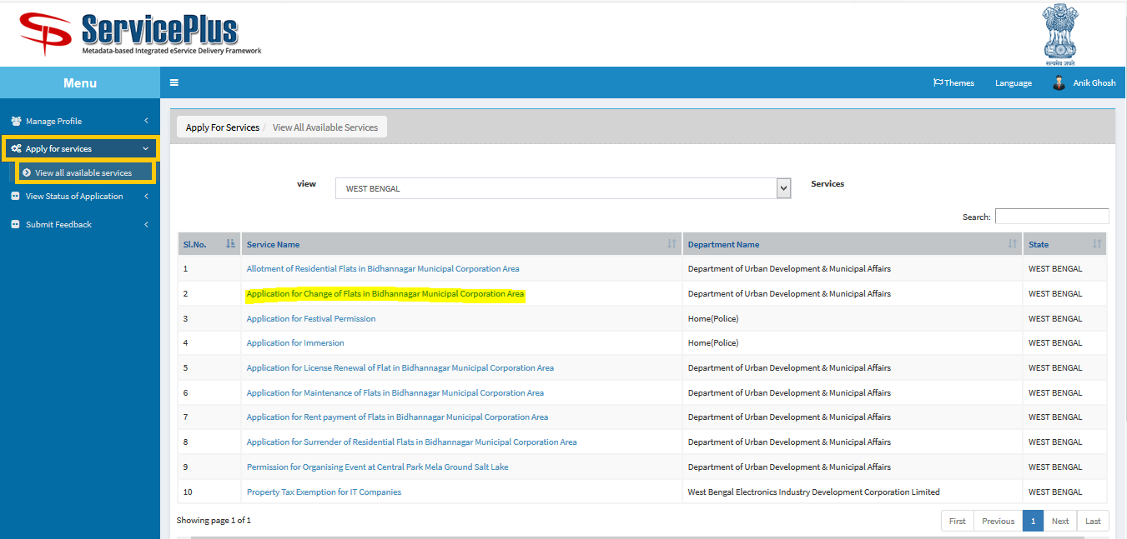

**Step -4:**

GiveCorrect **Flat No & License No** Then Click On **Get Data.**

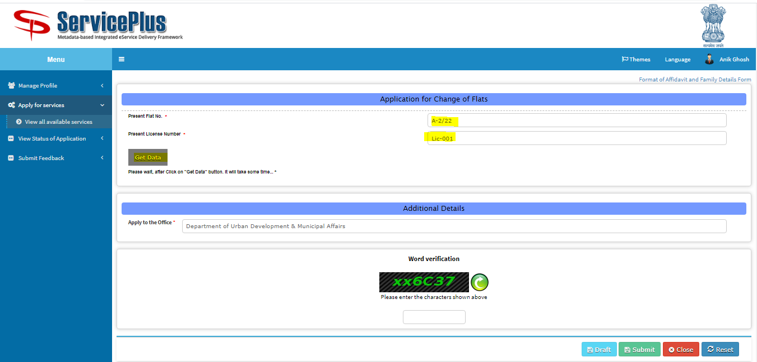

**Step 5:**

Now the Flat’s detail can be seen.

Select the proper **reason of change** of flat and **submit**.

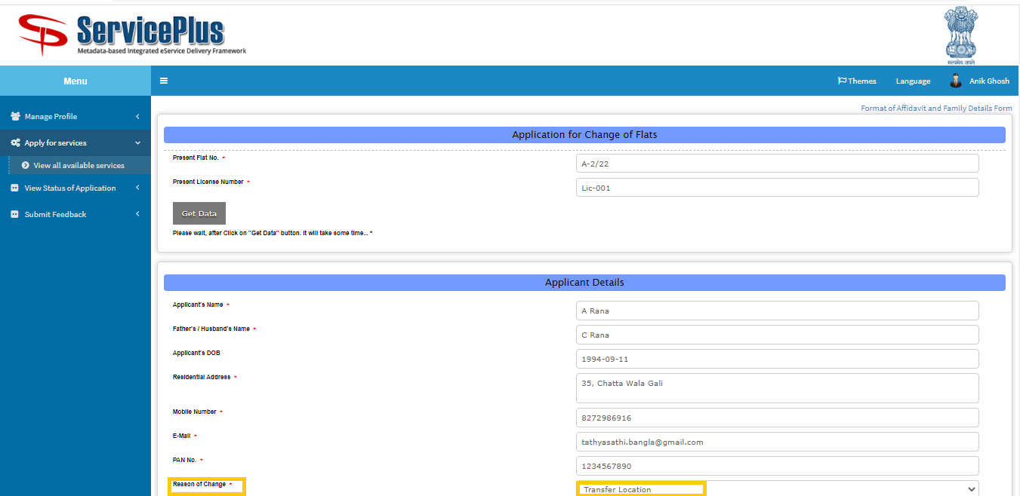

Enter the required **captcha** &clickon **submit.**

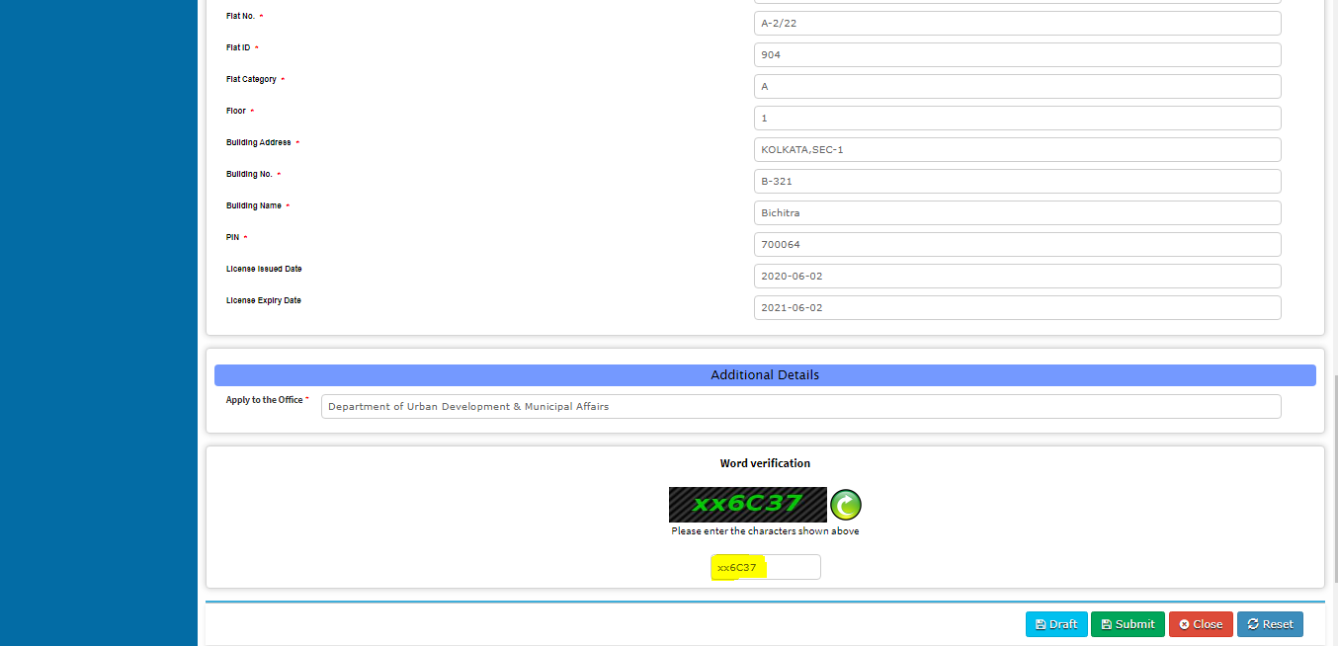

View the entered Data

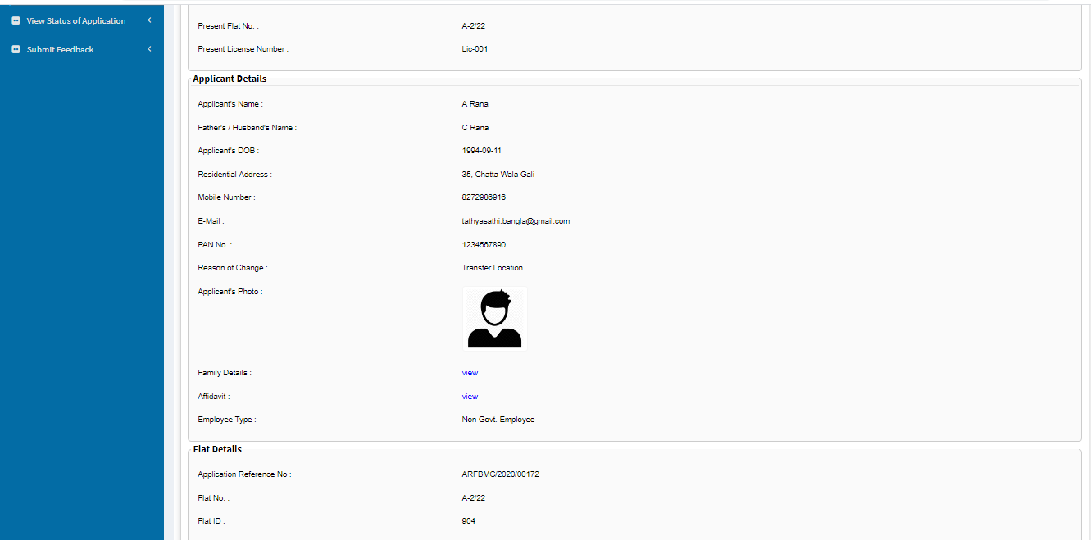

**Step 6:**

Now click “**Attach Annexure**” to attach your provided document.

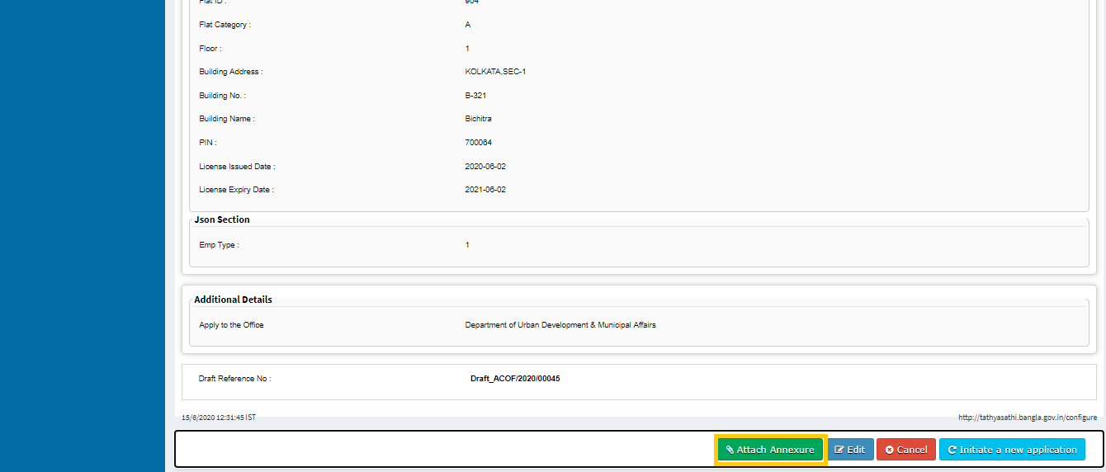

**Step -7:**

Now select the appropriate attachment and click on “**save annexure”**.

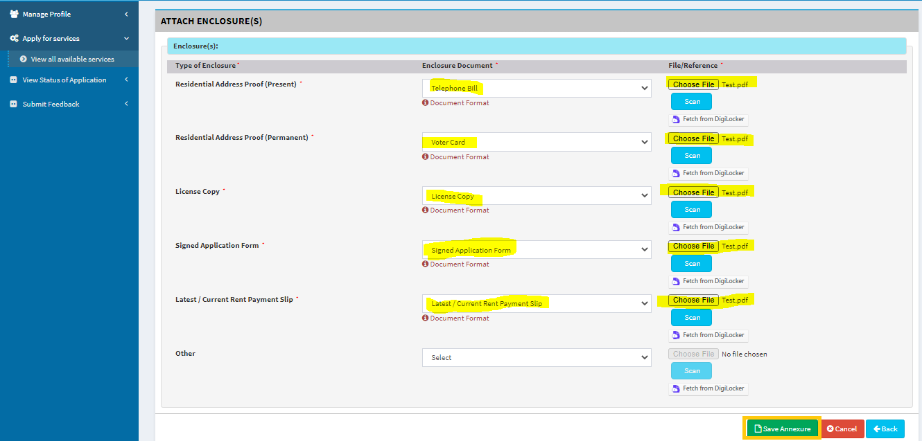

**Step -8:**

Now go through the form and click **submit** for applying.

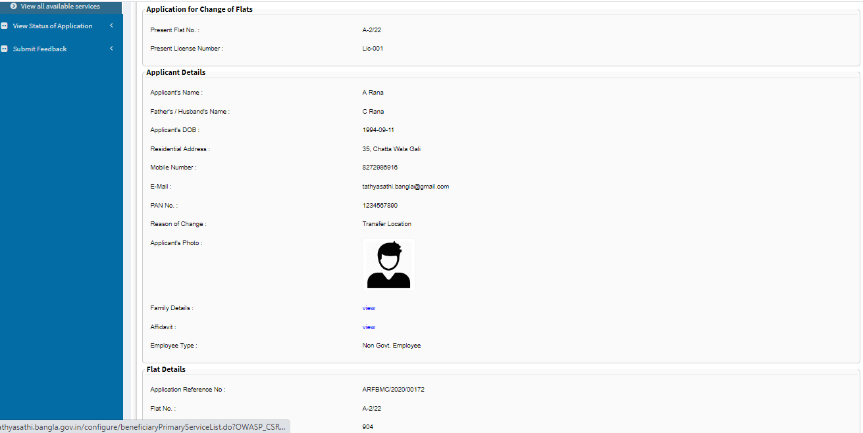

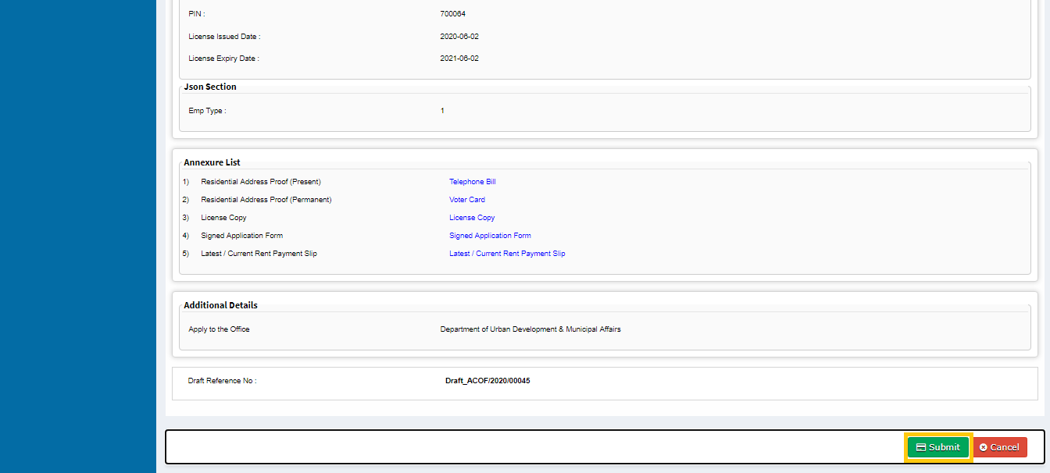

**Step -9:**

After Submission of form an acknowledgement slip is generated with **app reference number.**

Save by selecting “**Export to pdf”** or print it by selecting “**Print”**

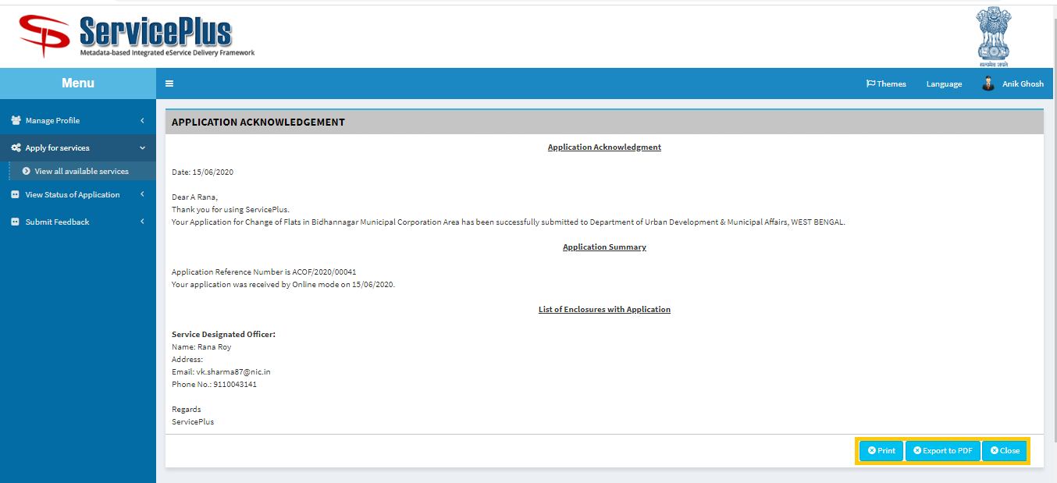

**This is the Application Acknowledgement**

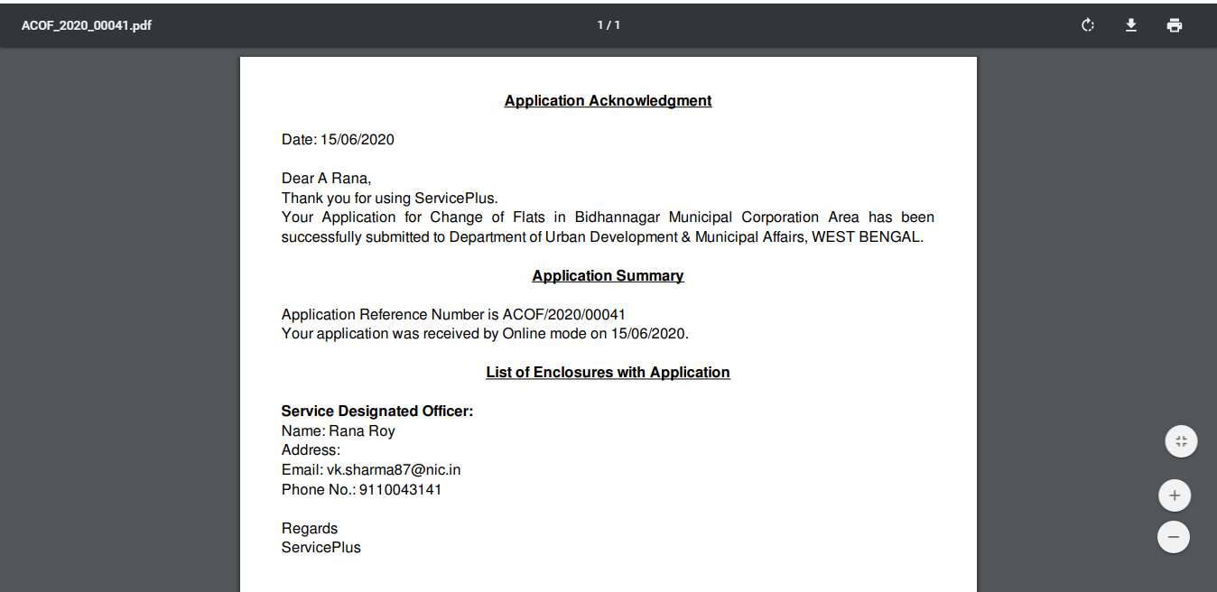

**PHYSICAL POSSESSION BY APPLICANT**

**Step -1:**

Click on **“View Status of Application”** and go to **“Track Application Status”.**

Here search with “**App ref no”** or **“From Date and To Date”** and Click “**Get Data”** button**.**

Click on “**Waiting for** **Applicant’s Response”** for the particular Application.

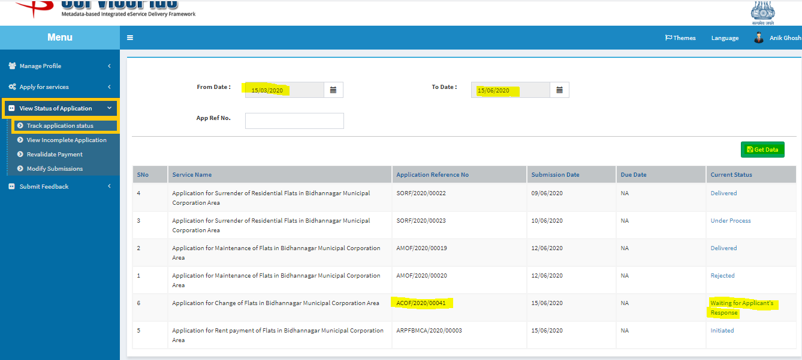

**Step -2:**

Click on **“Click Here”.**

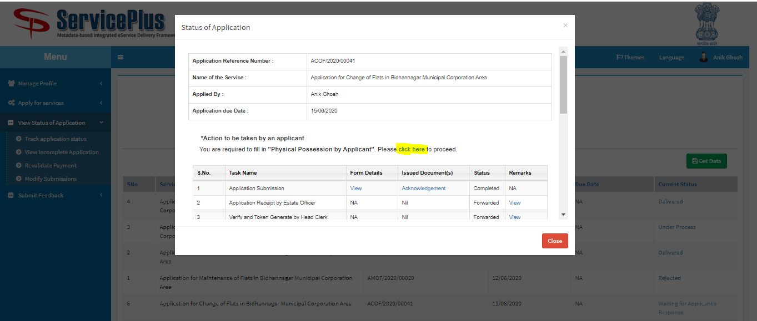

**Step -3:**

Upload all the required **Documents** & fill in the details and **Submit.**

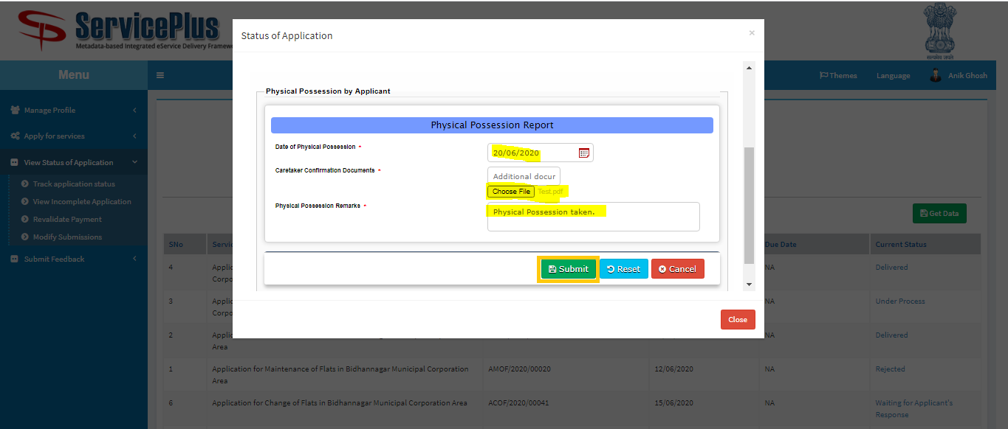

**Step -4:**

This message is shown after Successful Submission of the document.

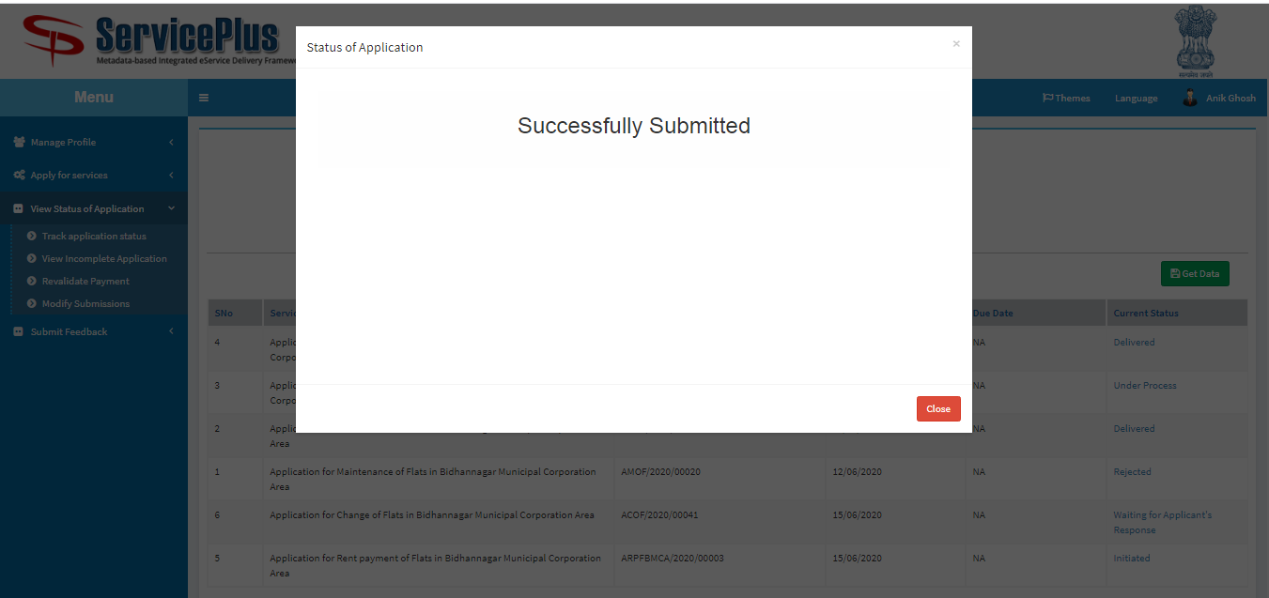

**SHORTFALL CASE**

**Step -1:**

Click on **“View Status of Application”** and go to **“Track Application Status”.**

Select parameter and click on **“Get Data”.**

Click on “**Waiting for** **Applicant’s Response”** for the particular Application.

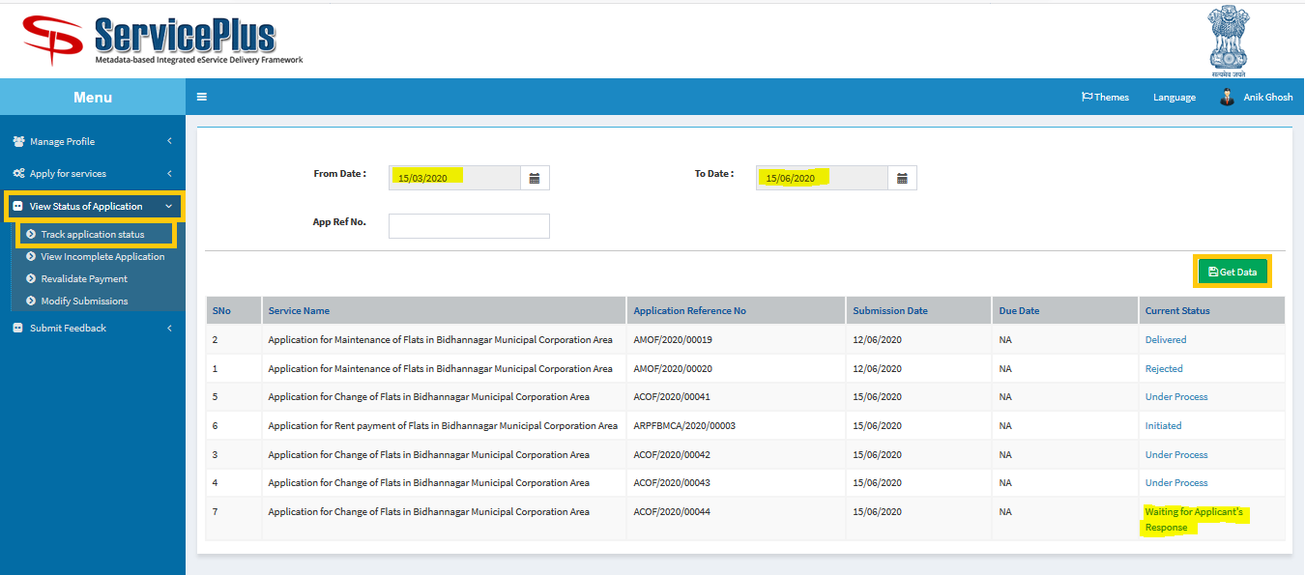

**Step -2:**

Click on **“Click Here”.**

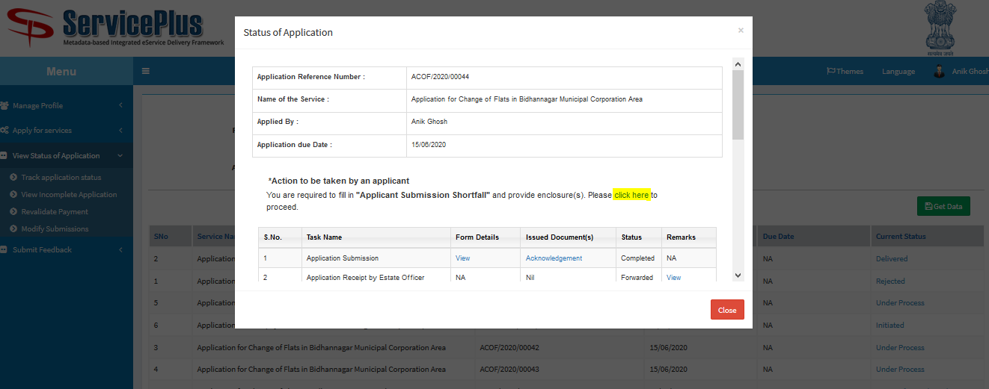

**Step -3:**

Give **Remarks** and **Submit.**

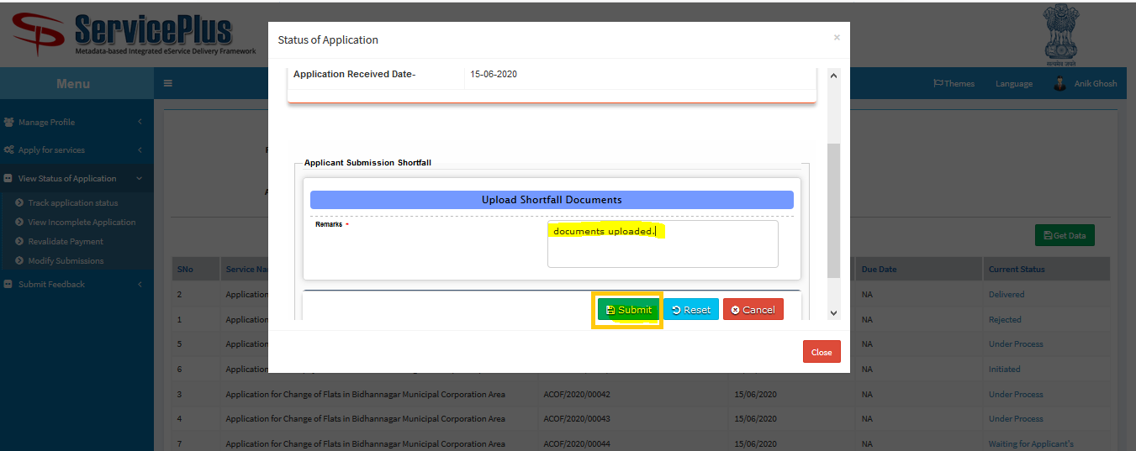

**Step -4:**

Upload the required documents and click on **submit** button.

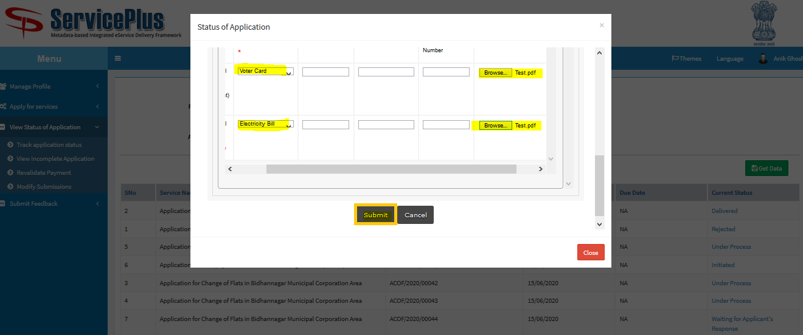

**Step -5:**

This message is shown after Successful Submission of the document.

